 | KENDRIYA VIDYALAYA TAMENGLONG
 | SUMMATIVE ASSESSMENT- II , 2015-16
 | CLASS: V SEC: ________
 | SUB: ENGLISH |  |  | TIME: 2 hours |  |  | DATE: ____________
NAME: _____________________________________ |  |  |  |  |  |  |  |  | ROLL NO : _____
COMPETENCIES |  | READING | WRITING |  |  |  |  |  |  |  | OVER ALL
 |  | READING | TEXT |  | GRAMMAR | CREATIVE WRITING |  | SPELLING |  | HAND WRIT. | OVER ALL
Value Points |  | 20 | 10 |  | 10 | 10 |  | 05 |  | 05 | 60
V.P. Obtained
GRADE
Signature of Invigilator : ________________ |  |  |  |  |  | Signature of Evaluator : ________________

READING ( 20 VP)
Read the following passage carefully and answer the questions. ( 10 X 1=10 VP)
On the 16th of June 1730 we discovered land. Our captain sent a dozen men with vessels for water, if any could be found. When we came to land we saw no river or spring nor any inhabitants, I went on to explore. The country was barren and rocky. I turned back to join the crew, only to see them getting into the boat and rowing for life to get to the ship.
Before I could reach them I observed a huge creature walking after them in the sea as fast as he could. The water of the ocean reached only till his knees. However the monster was unable to overtake the speeding boat. I turned back quickly and climbed up a steep hill with fields of barley on either side and the corn rising up to forty feet. There was a fence to pass from one field to the other.
- When did they discover land ?
Ans. _______________________________________________________________
- Why did the captain send a dozen men ?
Ans. _______________________________________________________________
- What did they see when they come to land ?
Ans. _______________________________________________________________
- What are the fields that are mentioned in the second paragraph ?
Ans. _______________________________________________________________
Make a sentence using the following words.
- Discover : ______________________________________________________
- Huge : ______________________________________________________
Write opposites.
- Fast X __________________
- Able X __________________

Write the meanings of the following words.
- Inhabitants = ______________________________
- Barren = ______________________________
Read the given passage carefully and answer the following questions. ( 10 X1=10 VP)
Tsunami is a Japanese word. In English it means “ harbour wave “. A Tsunami is a series of ocean waves generated by tectonic disturbances. Tsunamis that create killer waves are not produced by gravitational pull of the moon but due to abrupt shifting of the sea floor and resultant vertical displacement of overlying water. Waves are formed when the displaced water mass attempts to regain its equilibrium. The size of the resultant Tsunami waves is determined by the quantum of deformation of the sea floor. If the vertical displacement is more, the size of the wave will be bigger. The earthquake that occur underneath or near the ocean generate Tsunami.
1. What is the meaning of the word ‘ Tsunami ‘ ?
Ans. _____________________________________________________________
2. What is the language of Japan ?
Ans. _____________________________________________________________
3. A _______________________ is a series of ocean waves generated by tectonic disturbances.
4. What does the earthquake generate ?
Ans.___________________________________________________________________
Write the opposite words.
Ex. Dishonest X Honest
5. Displacement X _____________________
6. Deformation X _____________________
Fill in the blanks.
Ex. Large larger largest
7. big ____________ _________________
8. near ____________ _________________
Write the synonym of the following words.
Ex. Regain = to get again
9. abrupt = ________________________________
10. underneath = ________________________________
WRITING
Prose & Poetry (10 VP)
Answer the following questions. (5 X 2 = 10 VP)
1. Why was the Sultan in a hurry ?
Ans._________________________________________________________________________________________________________________________________________
2. The Topsy – turvy land is very different from our land. Let’s draw a comparision by filling in sentences wherever needed.
Topsy –turvy Land | Our Land
People walk on their heads.
 | The buses run on land.

3. Choose the correct answer.
a) The giant carried a reaping hook because
I ) he was fighting with the other giants.
II ) he was going to reap the corn.
B ) Gulliver was
I ) a sailor II ) a giant
4. Where did the polar bear live with her family ?
Ans._________________________________________________________________________________________________________________________________________
5. Choose the correct answer.
A ) Why did all the children hate Hari ?
Ans. I ) Because he would not talk to anyone II ) Because he always pinched them.
B ) “ Nobody took Hari’s hand. Nobody went near him. Nobody played with him.” This shows that Hari had
Ans. I ) many friends. II ) no friends.
GRAMMAR ( 10 )
- Fill in the blanks with appropriate articles ( a, an or the ). 5 X 1 = 5
- Hari was _________ unpopular boy.
- He saw _____________ big crab coming towards him.
- My father gave me __________ pen.
- I ate ___________ apple today.
- __________ sun rises in the east.
- Use the joining words given in the box to fill in the blanks. 5 X 1 = 5
or | if | where | Till | unless

- Please wait with me ______________ the bus arrives.
- Your speech cannot be heard by the audience ______________ you use a powerful mike.
- We will reach on time ______________ we go by the car.
- We went to the zoo _______________ we saw many animals.
- Do you like football _______________ cricket ?
CREATIVE WRITNG ( 10 )
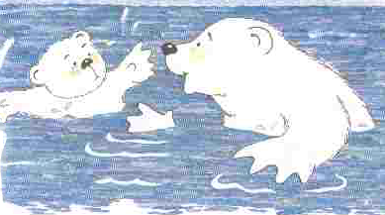
- Write a detailed character sketch of Malu Bhalu using the words given below. 1 X 5 = 5
White female
Brave and hardworking
Eager to learn more
Eager to learn more
Impatient
Clever
Fearless
loves

Ans.______________________________________________________________________________________________________________________________________________________________________________________________________________________________________________________________________________________________________________________________________________________________________________________________________________________________________________________________________________________________________________________________________________________________________________________________________________________________________________________________________________________________________________________________________
- Describe what is happening in the picture. Use is/are and -ing to make your sentences. Use the clues given below. 1 X 5 = 5
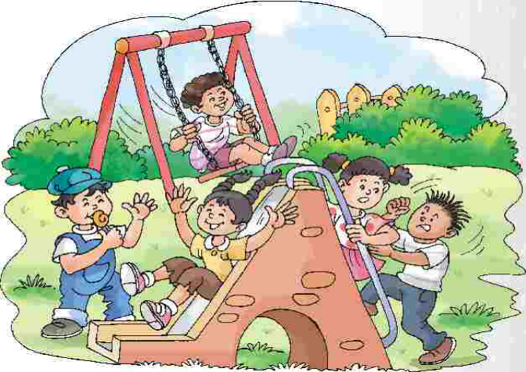
CLUES
Swing
Sit
Climb
Lick
Slid
kick

________________________________________________________________________________________________________________________________________________________________________________________________________________________________________________________________________________________________________________________________________________________________________________________________________________________________________________________________________________________________________________________________________
SPELLING
Encircle the correct word. 5 X 1 = 5
- QUCKLY QUICKLY QIUCKLY
- CUROSITY CUIORSITY CURIOSITY
- BRUISE BRUSE BRUIESE
- SOLDER SOLDIER SOLIDER
- EXCITEMENT EXTIMENT EXCTMENT
HANDWRITING
Respect plays a vital role in human life, which should be commanded and cannot be attained by demand.
It is respect that pays great dividends and gives us happiness and peace of mind. It is the heritage of all people. A person of respect has nothing to fear or lose, as he has everything to gain. If people do their duties and behave in a respectful way, they will be saved from all evils and misfortunes. A person of respect commands the love of esteem and is trusted. They are respected even by their enemies. Their reputation is high and they are regarded with admiration and love.
Write the above passage in beautiful handwriting. ( 1 X 5 = 5 VP)

Ans._____________________________________________________________________________________________________________________________________ ___________________________________________________________________________________________________________________________________________________________________________________________________________________________________________________________________________________________________________________________________________________________________________________________________________________________________________________________________________________________________________________________________________________________________________________________________________________________________________________________________________________________________________________________________________________________________________________________________________________________________________________________________________________________________________________________________________________________ All the best.

